Identifying Your Calling

Every individual, regardless of abilities or disabilities, is called to live a life that is glorifying to God. In addition, each of us are called to contribute to the body of Christ in a unique and meaningful way. Identifying your calling can be difficult, but we hope this resource will help make the process clearer.

The three main ingredients that can help identify your calling are passion, skills, and opportunities. As you make time to discover your calling, you will find it much easier to choose your next steps in ministry. Strive to remain within your calling as you serve—this generally leads to greater effectiveness as you lead.
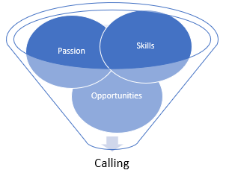
Identifying Your Calling

Passion: What keeps you up at night and pulls on your heart by day?

Skills: Identify your top five talents and abilities.*

Opportunities: What doors are currently in front of you that you can consider?

Passion___________________________________________________________________
_________________________________________________________________________
__________________________________________________________________________

Skills
- __________________________ 2. __________________________
- __________________________ 4. __________________________
- __________________________ 6. __________________________
Opportunities__________________________________________________________
_____________________________________________________________________
_____________________________________________________________________
*Consider Strengths Finder 2.0 as an excellent resource to help identify your top five talents and abilities.
For more information, visit irresistiblechurch.org

